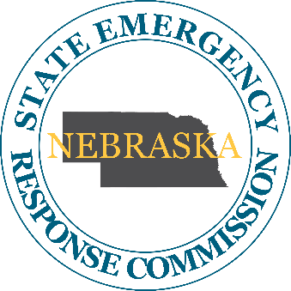
Nebraska State Emergency Response Commission

April 13th May 5th, 2023
Agenda
1:00 PM CDT
Nebraska Department of Environment and Energy
245 Fallbrook Blvd.
Lincoln, NE 68521
Join from the meeting link
https://sonvideo.webex.com/sonvideo/j.php?MTID=md1ef59b0aa1e55294414f0d789984c23

Join by meeting number
Meeting number (access code): 2491 321 3329
Meeting password: pKJc52B8AQA

- Call to Order
  - This Meeting has been duly advertised, proceeded by advance notice, and is hereby declared in open session in accordance with the Nebraska Open Meetings Act, a copy is available for review in the meeting room.
  - Member Roll Call
  - Introductions

- Approval of the agenda for the April May 2023 Meeting

- Approval of the minutes from the January 2022 Meeting

- New Business/Continued
  - By-Laws Review & Approval
  - LEPC Memberships
  - Open Seats of SERC Commission- Kim Plouzek
  - Sub-Committees
    - LEPC Hazmat Plans Review- Revision to review process

- Member and Stakeholder Reports
  - NEMA
  - NDEE
  - Other

- Open Discussion
- Public Comments

- Adjournment
  - Next Meeting July 12th , 2023 (245 Fallbrook Blvd. Lower Meeting Room 031 @ 1300 (CT))

